Over the years, Rimage embedded products have utilized a few different motherboard versions. In order to use the correct Recovery Disc or to check for compatibility with newer Operating Systems, knowing how to find out which motherboard you have is important.
The first method to determine your motherboard is through the Rimage System Manager software. The Rimage System Manager will list the motherboard version in the system information that can be found from the main page of the Rimage System Manager.
On Rimage Software Suite 9.1 and older, you can find the motherboard listed under the Operating System
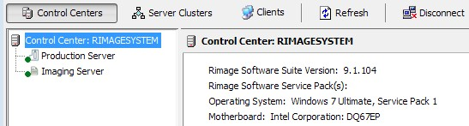

On Rimage Software Suite 9.2 or later, you can find the motherboard on the System tab of the Autoloader:
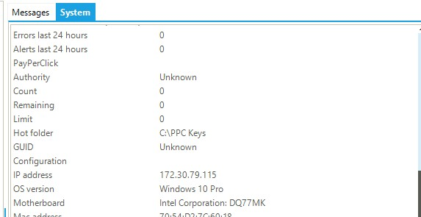

The second method for identifying the motherboard is to look inside the door or the back of the Rimage
system for a small sticker. This sticker will list “MB Q87” or similar, which would identify the motherboard. Older motherboards may not have this sticker, but all newer systems will.
The third method is to look at the peripherals on the I/O panel. Looking on the back of the system, you can match up the ports to the pictures below to identify the board:
Q45: 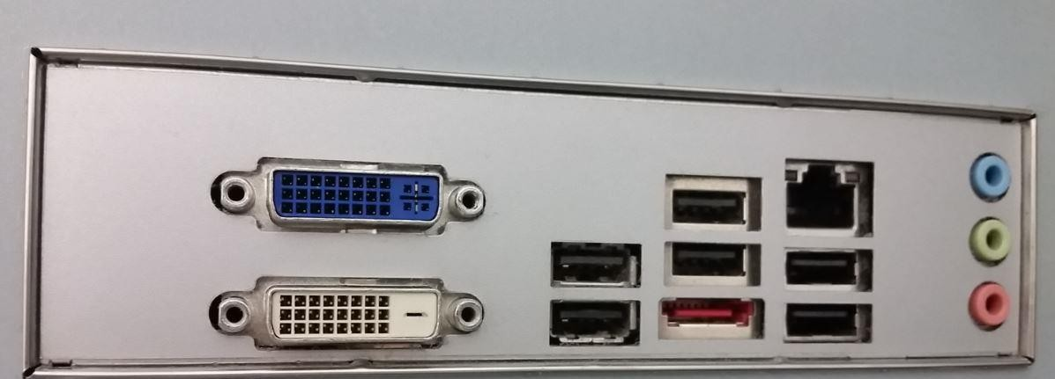
Q67: 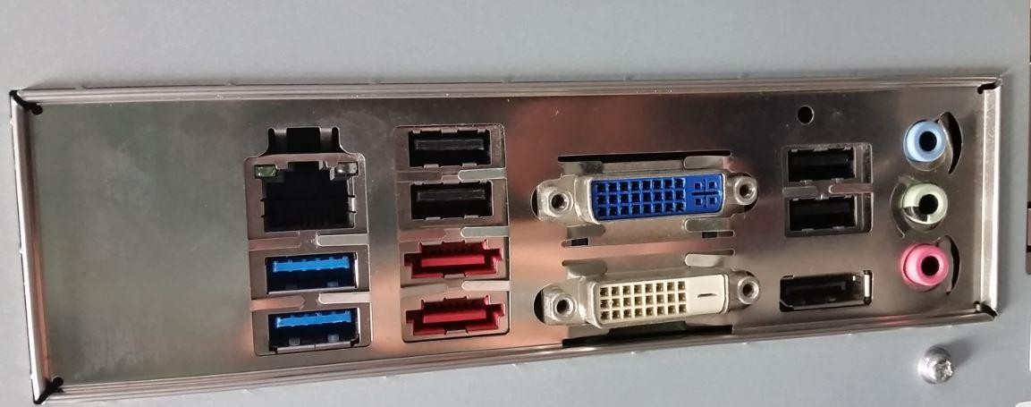
Q87: 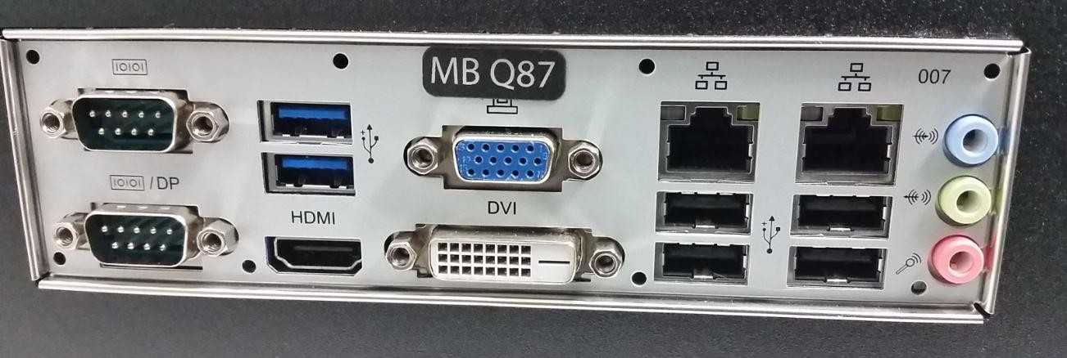

X11: 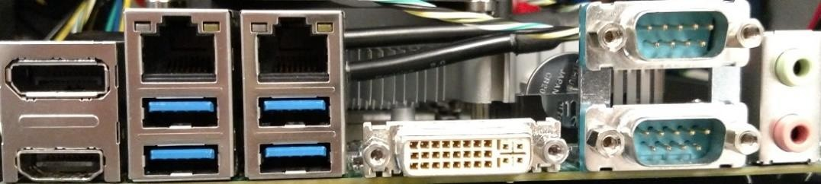

Q470: 