Everest 400 Firmware Update Inst. 2001942_A

Updating the Everest 400 Printer Firmware
The procedure in this document explains how to update the firmware on the Rimage Everest 400 printer. Firmware updates keep your printer running at peak performance. Updates can be performed on the external or embedded Control Center (PC) using the firmware downloaded from the Rimage Website.
This procedure is only for Everest 400 printers integrated in the Rimage 5410N, 5400N, 2410, 2400, 3410, 3400, or 2450 systems.

- Check your current firmware version.
  - Power on the autoloader.
Or
If the autoloader is already powered on, open and close the autoloader’s front door.
The operator panel displays system information.
  - When the panel displays [PROM_0506A_###_] note the number following the A_. This is the current firmware version.
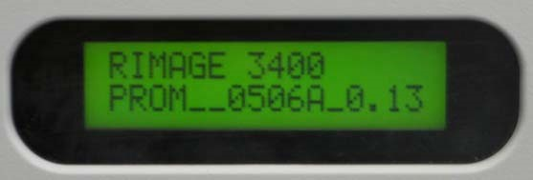

Firmware

Version

Number
  - Go to devices and printers, locate Everest 400 printer icon, right hand click or click manage, printer preference, utility, status monitor. Select the printer information tab, locate the ROM version this also will tell you the firmware version.

- Locate the latest firmware version at www.rimage.com/support.
  - Under the Quick Links header, click the “LATEST PRINTER FIRMWARE” link.
  - Then click the “Everest 400 Firmware – vX.XX” link.
  - If the firmware version on the Software, Firmware & Service Packs tab is newer than your printer’s current version, download the firmware. Refer to step3.
If the firmware version listed is the same as your printer’s current version, no further action is needed. Periodically check the Rimage Support site for firmware version updates.
- Download the latest firmware version.
  - At the PC, create a new folder on the C:\ drive labeled Updated Firmware.
  - From the Everest 400 Firmware - V0.51 page, click the “0506AXXX.hex” link to download the latest firmware file.
  - Save the 506A###.hex file to the C:\Updated Firmware folder that you created in step 3b
  - Click the “Ev Updater 2.1.1.0.zip” link to download the firmware install utility.
  - Save the Ev Updater 2.1.1.0.zip to the C:\Updated Firmware folder.
- Open the .zip file saved to the Updated Firmware folder.
- Double‐click the EV3+Updater.exe file contained in the .zip file.
- Click the Select File button, browse to the C:\Updated Firmware folder, select the 506A###.hex file, and click the Open button.
- Click the Update Flash button.
The updater runs and the firmware installs. The system is ready for use.
Rimage Corporation © 2010 June 11,2021 1

