ProducerV Operator

Gripper Alignment
Use this procedure to adjust the gripper into proper alignment with the Carousel, Recorders, and Printer.

Required Tools
• Torx 10 Screwdriver
Before you Begin
• Check the alignment of the arm at each location – Carousel, Recorder, and Printer.
If the arm is out of alignment at all three locations, proceed with this procedure. If the arm is out of alignment at only one location, then that location should be aligned individually.

Align the Gripper
- Raise the arm above the printer tray
- LOOSEN (do NOT fully remove) the screw on the underside of the gripper.
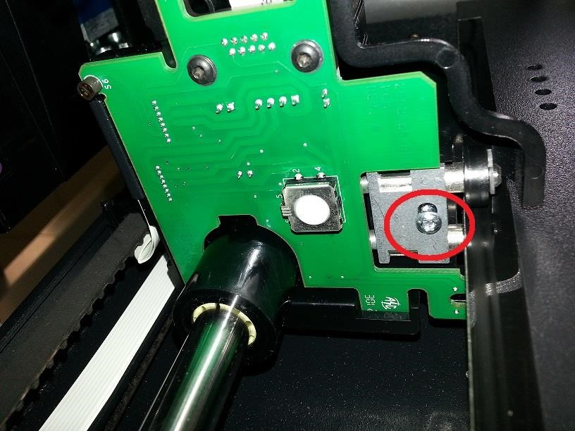
With this screw loosened, the arm will freely rotate on the rail.

- Place a disc on the gripper assembly.
Hold a disc against the picker hub, press and release the white button on the underside of the griper to fire the solenoid.
- Open the printer tray by pressing the button on the printer.
- Lower the arm until the disc is gently resting on the printer pad.
- Move the arm back and forth slightly. You’ll notice you can only push it back so far till it hits the metal piece sticking up through the center, and you can pull it towards yourself only so far till it hits the edge of the tray. You will want to position it in the middle of this movement.
- Tighten the screw to secure the alignment. You will need to hold the arm in place while tightening up the screw otherwise the arm will go back to its previous alignment spot.
- Check to make sure the arm is properly aligned with the Recorders and Carousel.

