Everest 600/Encore Diagnostic Tests
The following are the tests you can do while the Everest 600 or Everest Encore is in Diagnostic Mode (Mode 3). This switch is found on the back of the printer to the right of the USB cable. With the power unplugged from the printer, turn the white nob clockwise till you see the number 3 shown, see picture below.
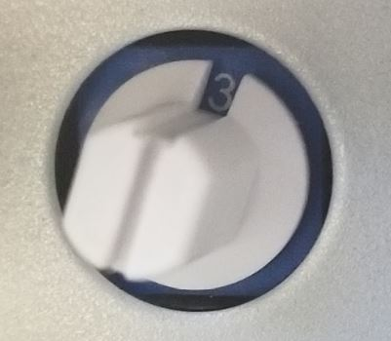
Now plug in the printer, after about 5 seconds you should have two lights lit on the front. The two lights are the green power light and the orange connectivity light.
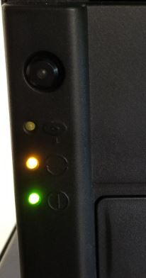

To use a tests described on page 2 press the button on the printer button that many times and hold on the final press. For example to open the printer tray, press the button 12 times and on the 12th press hold it down. Once you hear a noise from the printer you can release the button. The orange activity light on the printer will flash while the printer is doing the action requested. Once it done with the action, the light will stop flashing and go back to solid.
Once you are done running the test(s), pull the power plug from the back of the printer. Change the mode nob on the back of the printer back to mode 2, and then plug the power back into the printer. Then power cycle the entire machine including the autoloader portion.

Test No. | Test Description
1 | The platen cleaning mode
2 | The re-transfer heat roller cleaning mode
3 | Print Color Position Check Pattern and Printing Head Check Pattern
4 | Print Full Dot Pattern
5 | Print Gray Scale at a variable dot of 16 levels (Vertical)
6 | Print Gray Scale at a variable dot of 32 levels (Horizontal)
7 | Burn-in (Close and open the drawer, lower and raise the printing head, lower and raise the re-transfer heat roller for 1000 cycles)
8 | Lower and raise the printing head
9 | Advance the ribbon
10 | Close the drawer
11 | Clamp the DISC
12 | Open the drawer
13 | Advance and rewind the re-transfer sheet
14 | Lower and raise the re-transfer sheet
15 | Turn on and turn off the halogen lamp
16 | Start and stop rotating the re-transfer heat roller
17 | Turn on and turn off the Actuator
18 | Turn on the cooling fan
19 | The printing head position sensor
20 | The ribbon sensor
21 | The re-transfer heat roller position sensor
22 | The drawer close sensor
23 | The drawer open sensor
24 | The thermometer for the printing head
25 | The thermometer for the re-transfer heat roller
26 | The thermometer for the environment temperature
27 | The transfer position sensor for the surface of DISC
28 | The printing position sensor for the re-transfer sheet
29 | The tension sensor 1 for the re-transfer sheet
30 | The tension sensor 2 for the re-transfer sheet
31 | The cover open sensor
32 | The release lever position sensor for the printing head
33 | The release lever position sensor for the re-transfer heat roller
34 | The DISC sensor
35 | The DISC clamp sensor
36 | The lock lever for locking frame position sensor
37 | The re-transfer sheet motor encoder
38 | The heat roller motor encoder
39 | The drawer motor encoder

