Rimage CATALYST/PV

Replacing RAM 4 GB against 8 GB
In CATALYST and 8300N, MB X11 we have dual slot RAM with dual Channel to use 2 x 8GB RAM by replacing 2 x 4 GB RAM.

Required Tools
Torx 10 screwdriver
00 Philips screwdriver
2 x Part#2005057 (RAM 8GB DDR4 2666 SODIMM 1.2V CL19)

Replacing 2 x 4GB RAM against 2 x 8 GB RAM
- Remove the 8 Torx 10 screws from the back panel of the Catalyst II machine.
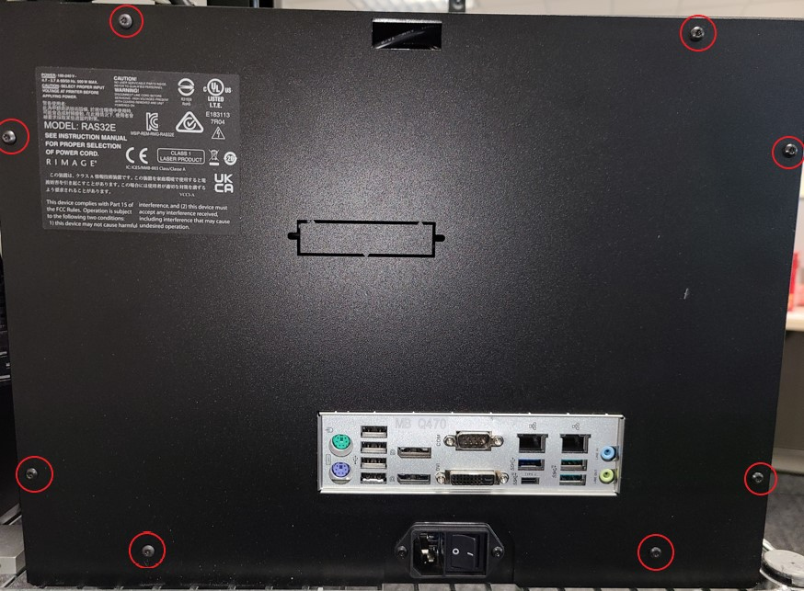

2.) Locate the position of RAM on Motherboard:
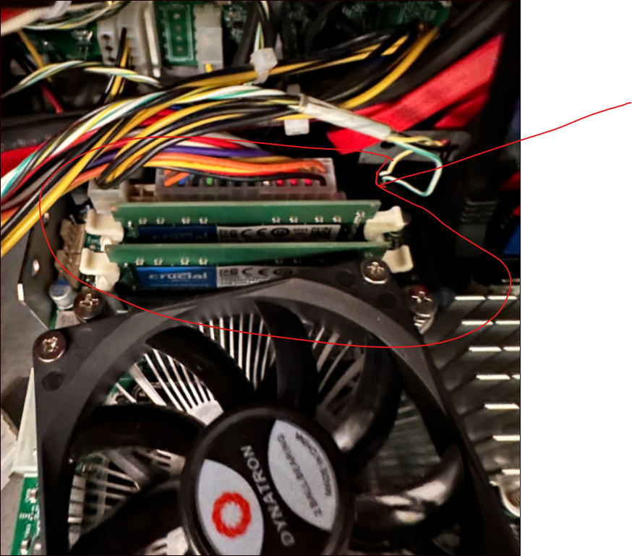

3,) Unlatch the RAM Lock:
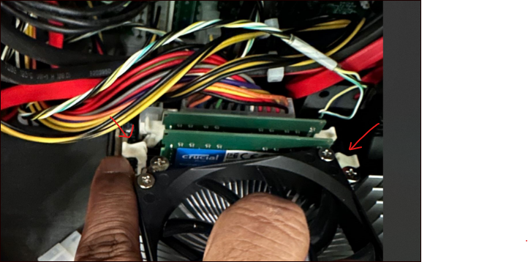

4.) Pull out the 4 GB RAM:
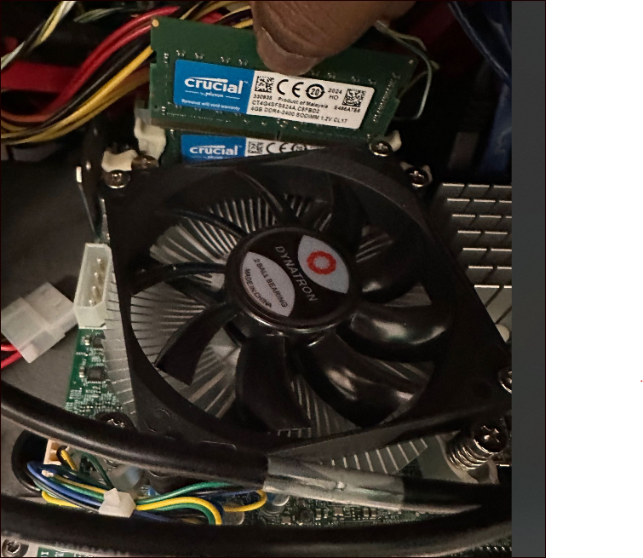

5.) Finally push the 8 GB RAM and lock the latch:
