Replace M.2 Drive in CatalystII

Replace M.2 Drive in CatalystII
This document will go through the steps to help you replace the M.2 drive on CatalystII machines with the Q470 motherboards.

Required Tools
- Torx 10 screwdriver
- 00 Philips screwdriver
- Rimage replacement M.2 drive
Before You Begin
- Power off the Rimage system
Removing the M.2 Drive
- Remove the 8 Torx 10 screws from the back panel of the Catalyst II machine.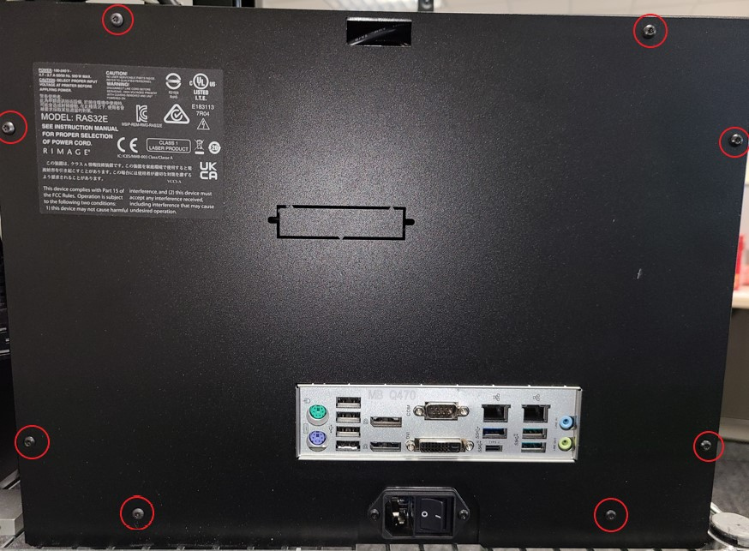
- Locate the M.2 Drive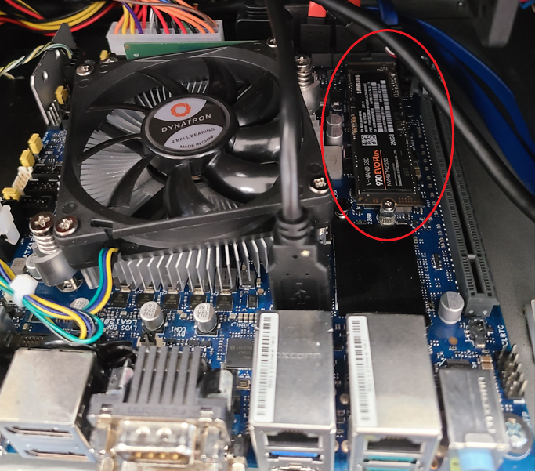
- Remove the philip screw that holds the drive down.
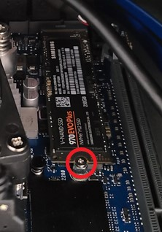
Notes:
  - Once the screw is removed the drive will spring up a little bit
- Pull the M.2 drive out straight from the top socket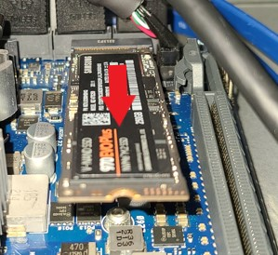
- Insert the replacement M.2 drive into the top M.2 slot, with the notched to the right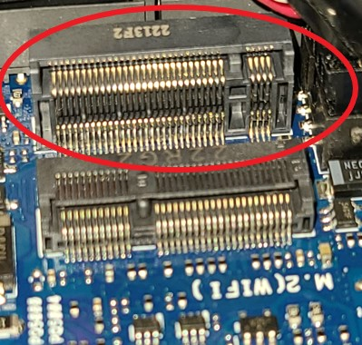 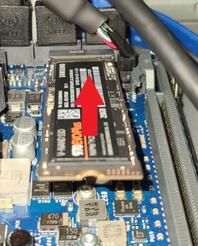
- While holdind the drive down, fasten it in place with the screw removed in step 3
- Put the back panel back on with the 8 screws removed in step 1

