The following guide will walk you through the steps on how to rebuild the RAID on the Rimage ProducerV and Maestro systems without running the recovery disc.

Requirements
You will need local admin rights on the box. You will be using Services.msc, Computer Management.

RAID Setup:

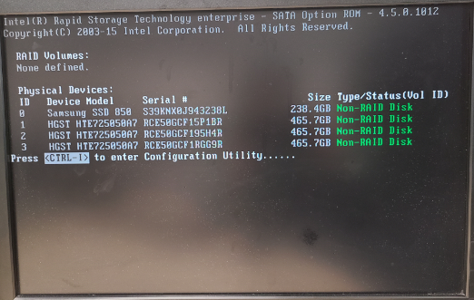
To create a new RAID press CNTRL+I on the Intel Rapid Storage Technology screen.
Once in the Rapid Storage settings select option 1. Create RAID Volume.
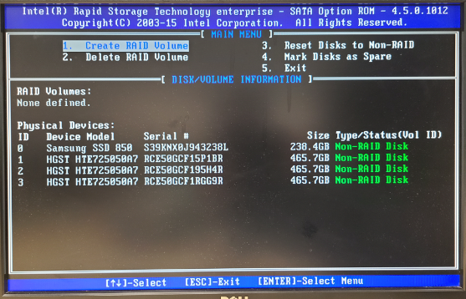
On the Create Volume Menu screen we will leave the Name as Volume0, and the RAID Level as RAID0(Strip). Press enter three times and we should now be in the Select Disks option.
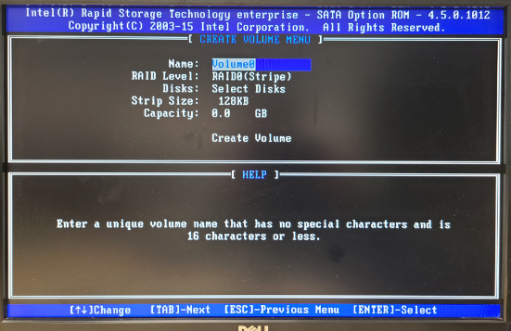
Select the 3 disks that are 465.7GB in size or larger by using the down arrow and pressing the space bar on each one. You should have a green arrow to the left of those three drives when done. Do not select the SSD drive or data loss will result.
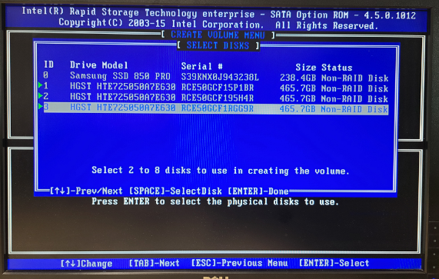
Press Enter and you should now be back at the previous screen with the Strip size selected
Press Enter 3 times leaving the stripe size at 128KB, the capacity at default size and asking to confirm creating the RAID.
Press Y to confirm the RAID
Press 5 to Exit RAID setup

Formatting the new partition:
Launch Computer Management application.
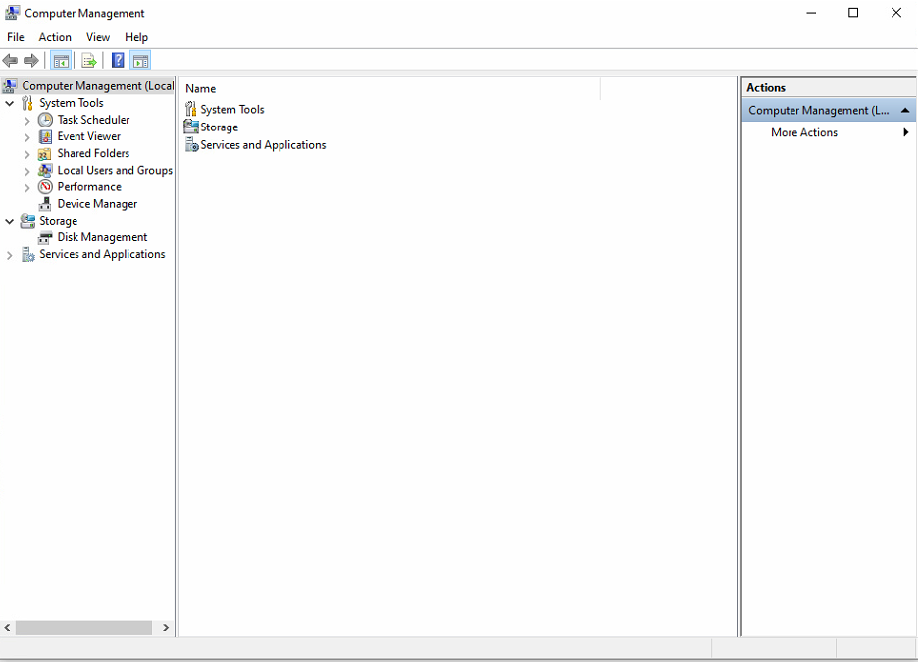
Open Disk Management and select Disk 1 and make sure you have MBR selected and press OK.
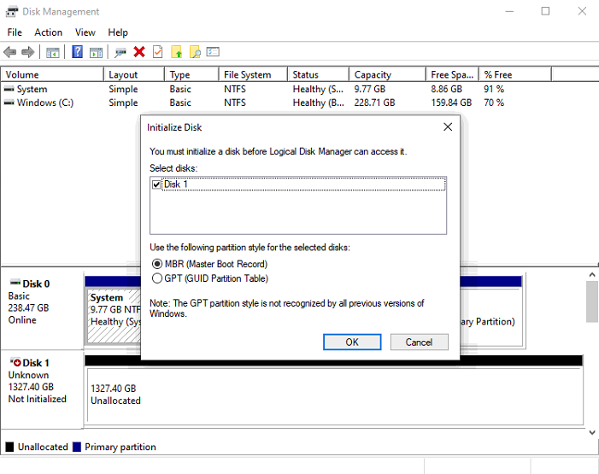

Right click on the Unallocated box for Disk 1 and select New Simple Volume.
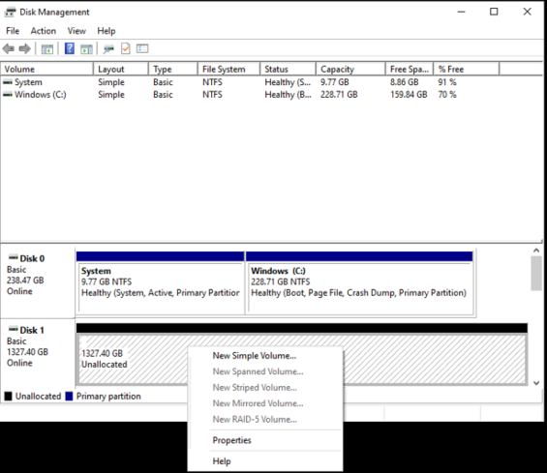
Keep clicking next through the New Simple Volume setup wizard till you reach the Assign Drive Letter or Path screen.
Select Assign the following drive letter and have it set to D then click next
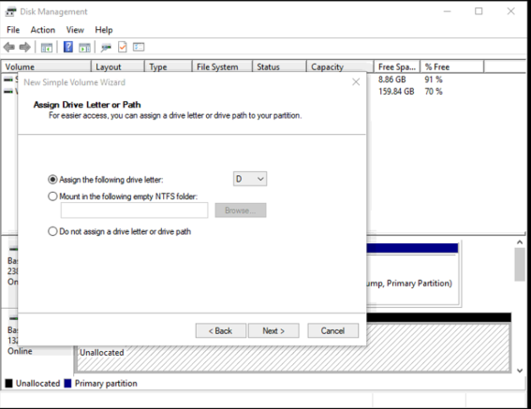
On the Format Partition screen, select Format this volume, set File system to NTFS, Allocation unit size to Default, and Volume Label to Data. Select Perform a quick format and click next.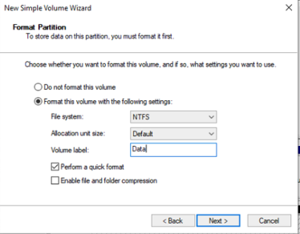
Click finish.

Running Rimage Repair
Open services.msc and scroll down to the services that start with Rimage. Look at Rimage messaging server and pay attention to the Logon account. You will need to know the password for this account to repair the Rimage software.
Place the Rimage disc in one of the recorders in the Rimage machine and run the DistSetup.exe file from the root of the disc.
On the Rimage Software Suite installation page fill in the following data
Domain: This will be the name of the Rimage, should already be filled in but double check
Account: This is the account that will be used for the services that we got from the step above
Password: This will the password that works for the account above
Confirm: This is the password being confirmed
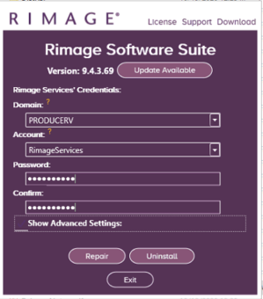
Now press Repair.
One repair is completed, you can remove the disc from the disc drive and restart the machine.

